Learning Summary Report

|  |  |  |  |  |
| --- | --- | --- | --- | --- |
|  | Pass | Credit | Distinction | High Distinction |
| Self-Assessment (please tick) |  |  |  |  |

*Self-assessment Statement*

|  |  |
| --- | --- |
|  | Included (please tick) |
| Learning Summary Report (This document) |  |
| Assessed Pass Tasks |  |
| Semester Test |  |

*Minimum Pass Checklist*

|  |  |
| --- | --- |
|  | Included (please tick) |
| All of the Pass requirements |  |
| Evidence of credit tasks that have been completed |  |

*Minimum Credit Checklist, in addition to Pass Checklist*

|  |  |
| --- | --- |
|  | Included (please tick) |
| All of the Credit requirements |  |
| Code for your program that demonstrates good OO design *including the use of polymorphism, implementing an interface and managing collections of objects*. |  |
| UML class diagrams and UML sequence diagrams that communicate the design your custom program |  |
| Description of what your program does and screenshots of your program in action |  |

*Minimum Distinction Checklist, in addition to Credit Checklist*

|  |  |
| --- | --- |
|  | Included (please tick) |
| All of the Distinction requirements |  |
| Research report and associated pieces |  |

*Minimum High Distinction Checklist, in addition to Distinction Checklist*

# Introduction

This section summarises what I learned about Object Oriented Programming. It includes a justification of the assessment pieces included in the portfolio, details of the coverage of the unit learning outcomes, and a reflection on my learning.

# Overview of Pieces Included

Briefly describe what you have included in each section of the report.

# Coverage of the Intended Learning Outcomes

This section outlines how the pieces I have included demonstrate the depth of my understanding in relation to each of the unit’s intended learning outcomes.

## ILO 1: Object Oriented Principles

*Explain the principles of the object oriented programming paradigm specifically including abstraction, encapsulation, inheritance and polymorphism.*

The following pieces demonstrate my ability in relation to this ILO:

* Test 1: questions … demonstrates …
* …

[Describe the you have included in your portfolio that demonstrates you ability in relation to each outcome.]

## ILO 2: Language Syntax

*Use an object oriented programming language, and associated class libraries, to develop object oriented programs.*

…

## ILO 3: Writing Programs

*Design, develop, test, and debug programs using object oriented principles in conjunction with an integrated development environment.*

…

## ILO 4: Object Oriented Design

*Construct appropriate diagrams and textual descriptions to communicate the static structure and dynamic behaviour of an object oriented solution.*

…

## ILO 5: Program Quality

*Describe and explain the factors that contribute to a good object oriented solution, reflecting on your own experiences and drawing upon accepted good practices.*

…

# Reflection

## The most important things I learned:

[ Think about topics covered, but also other general things you may have learned. Think about what you have learned in this subject, and reflect on what you think were key learning points, or incidents. Did you learn what you wanted/expected to learn? ]

## The things that helped me most were:

[ List and explain ]

## I found the following topics particularly challenging:

[ List and explain – if none explain why ]

## I found the following topics particularly interesting:

[ List and explain – remove if none ]

## I feel I learned these topics, concepts, and/or tools really well:

[ List and explain – if none explain why, refer to your pieces for evidence to support your claims ]

## I still need to work on the following areas:

[ List and explain – if none explain why, refer to your pieces ]

## My progress in this unit was …:

[ Include a screenshot of your **progress graph** from the ***COS20007 Portfolio Work Progress.xlsx*** file provided]

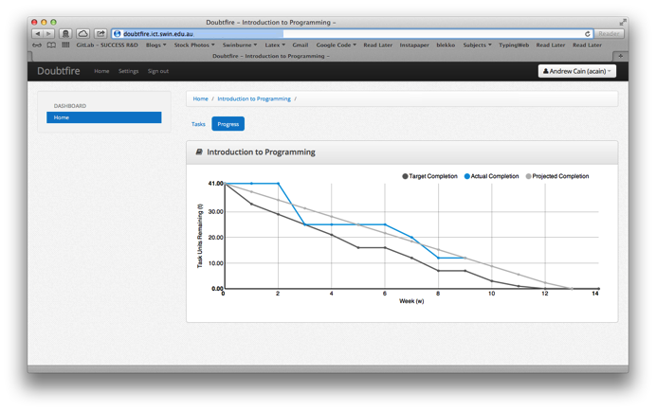

## This unit will help me in the future:

[ How will the things you learned relate to the rest of your studies, and career. What have you learned that will be valuable for you in the future? ]

## If I did this unit again I would do the following things differently:

[ List and explain, how will you approach learning in the future? What things worked well, but what could you change to make sure you did better next time?]

## Other…:

[ Add any other reflections you think help you demonstrate your learning ]

# Concluding Statement

In summary, I believe that I have clearly demonstrate that my portfolio is sufficient to be awarded a …. grade.

*[add more…]*